Trilix Ltd
Company Profile

- Privately owned company headquartered at Zagreb, Croatia – EU, established at 2007.
- Trilix invented Digital Services Distribution System – DSDSTM, a total end to end solution for creation, warehouse management, sales and delivery of advanced digital services from multiple service providers to various delivery devices, through a complex distribution chains.
- Microsoft awarded DSDSTM as the best global solution in High Volume Computing Solution category for 2009.

Vision and Mission

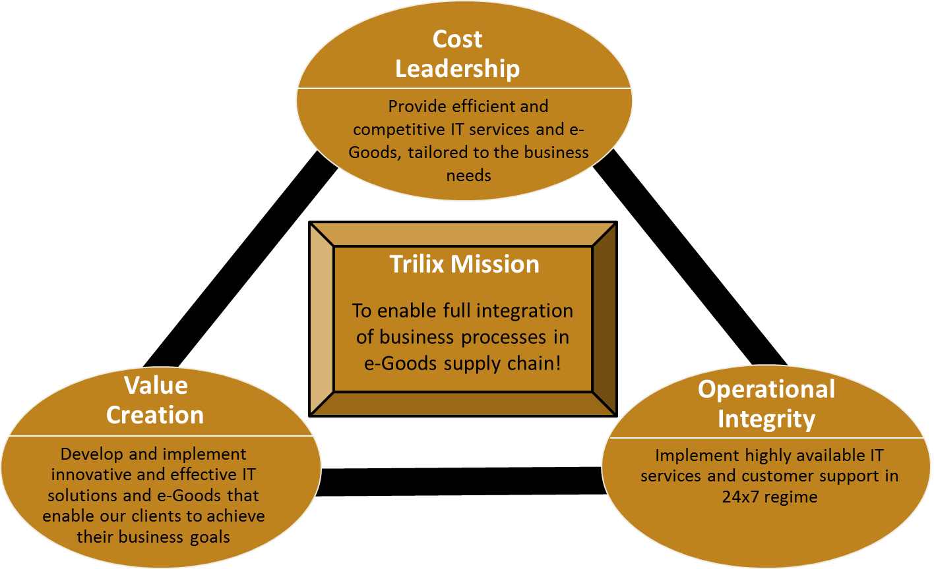

Customer support is at hart of every project
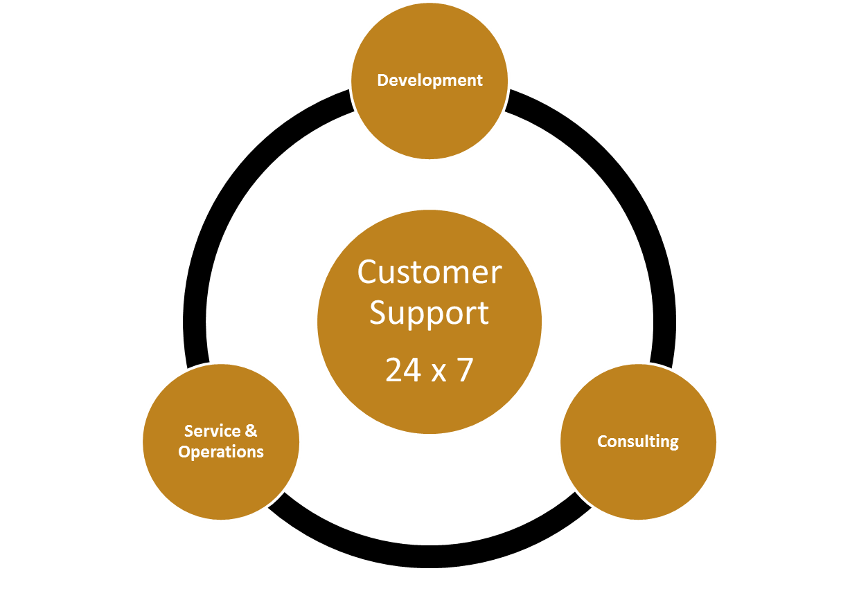

Operational excellence – we are commited to quality
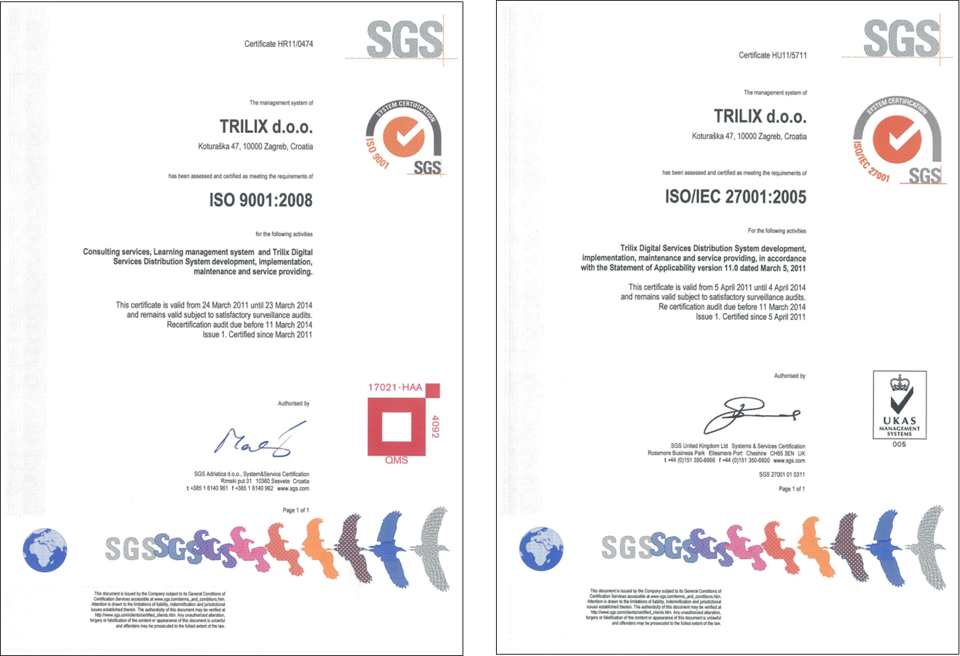
DSDS™ in brief – Trilix`s Flagship product

What is it?
Trilix Digital Services Delivery Solution (DSDS™) is a total end to end solution for advanced creation, warehouse management, distribution and sales of digital services and e-Goods from multiple service providers to various delivery devices, through a complex distribution chains.

What does it provide?
Trilix DSDS™ provides complete solution that covers complete e-Goods lifecycle from creation to final utilization allows users to purchase and/or use e-Goods at any digital device capable to request and receive information in digital form.

Future?
In order to protect your investment, Trilix regularly spread DSDS™ functionalities and borders with new technologies like NFC. Trilix is constantly expanding DSDS™ through integrations with different IT/IS systems for automation purpose and access to newest communication channels like social networks.

Digital distribution channel elements
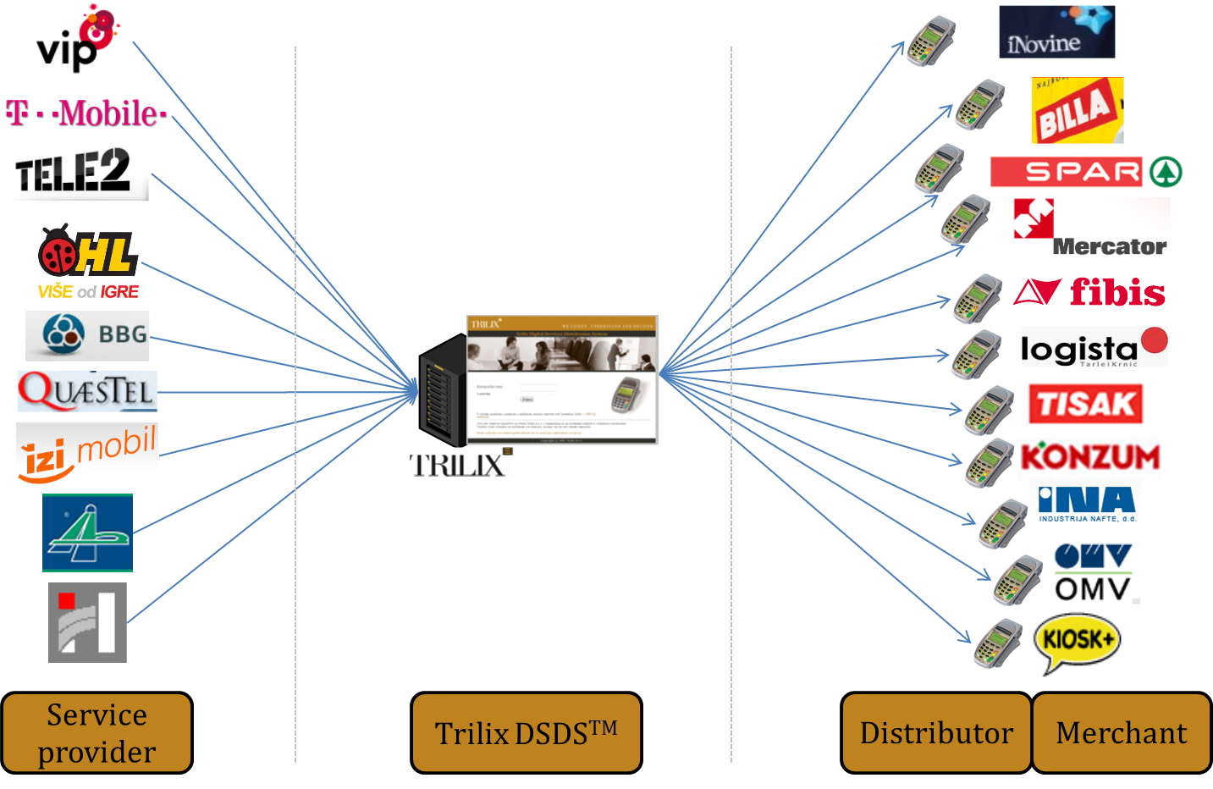

Domains of expertise
- Java programming language
- Java EE - enterprise applications
- Spring framework (MVC)
- Grails framework - web development
- MS SQL Server and MySQL Server

- Mobile development: Android, iOS, Windows Phone platforms
- Xamarin – App based mobile development
- PhoneGap – Web based mobile development

- MS SQL Server Reporting Services
- Bazaar version control system
- SFTP servers - Bitwise SSH server
- Open SSL - SSL/TLS protocols
- Python - testing script support

- SPDH
- ISO 8583
- Big ISO
- MDB 3.0

Trilix Ltd products & services

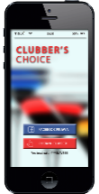
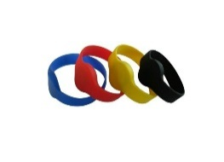
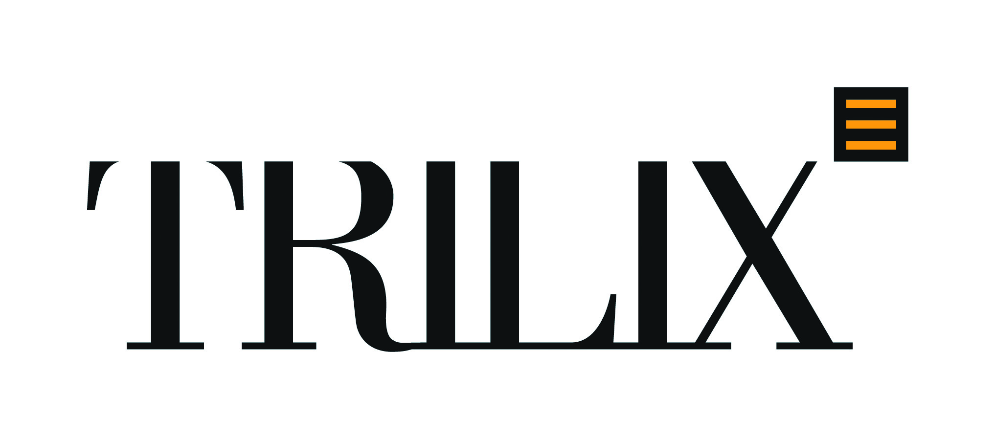

The best of all is that we easily combine functionalities of our products in single final solution to satisfy every particular Client needs!!!
Because we listen, understand and deliver!

